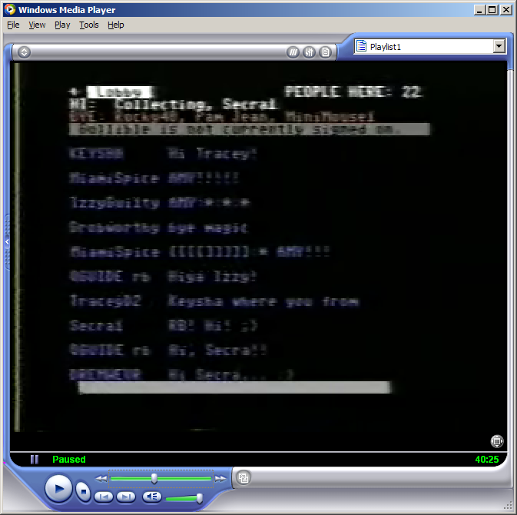
Result of Locate (not signed in)
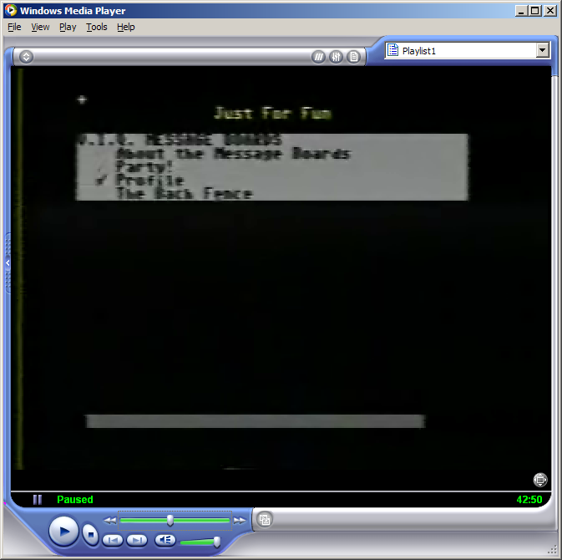
Message board (The Back Fence)

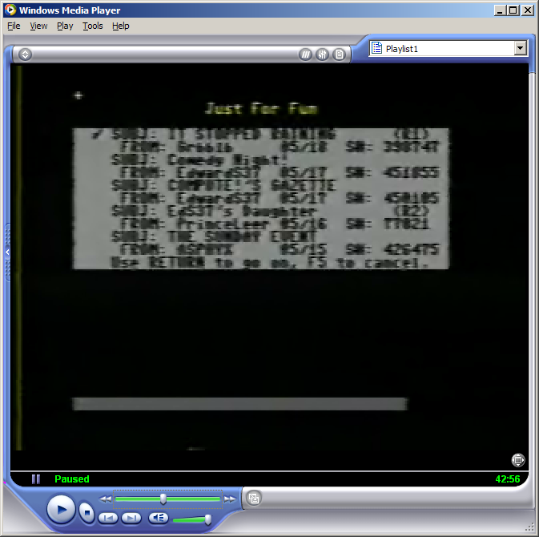

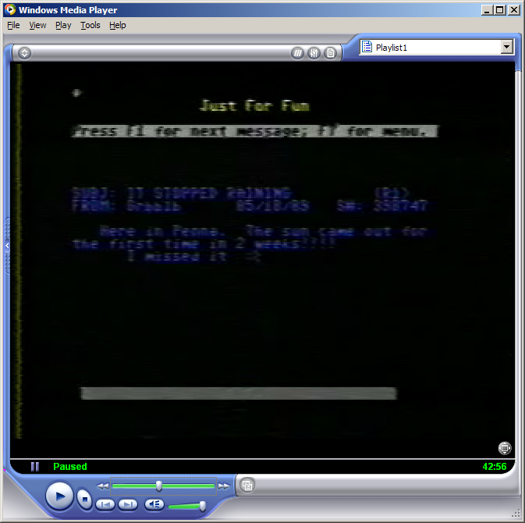
Message format

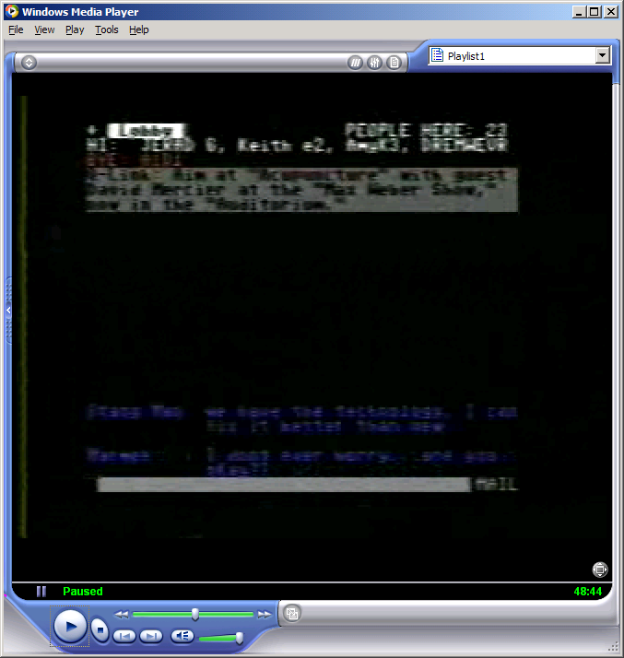

48:31 Q-Link: Aim at “Acupuncture” with guest David Mercier at the “Max Weber Show,” now in the “Auditorium”

Bottom of banner msg in auditorium

What do you think of the use of acupuncture? Have you ever had it done? Exactly how safe is it?

Stay tuned and join Max onstage to ask YOUR questions in person

(one space before each line)

…..<PRESS F5 TO CONTINUE>

48:58
Q-Link:
Quantum is pleased to award a door prize at each event held in the Q-Link
Auditorium. Winner names are generated by the Q-Link computers from among guests
Present in the Auditorium

A bit before 49:15

Q-Link (column 15)-=* Featured Events *=-
Column 12 for next stuff:
MM/YY Checkers Tourney10:00pm
3 lines and then a blank line
Q-Link only shows on first one

INFO Forum
Checker’s Tourney
Adult Vices
Timeworks
RUN Forum
Broderbund Forum
Pet Care Forum
Homes Today
YAY! It’s WHEEL!
Scout? Bartlett

49:45
Q-Link The Q-Link Auditorium can accommodate up to 200 guests. Other PEOPLE CONNECTION rooms
Limit “occupancy” to 23. To see the number of members in the Auditorium, press F7 for
Your menu. Select “Leave the Auditorium”. From that menu, you can “list” all public
rooms.

50:05
Q-Link For in-depth information about the Auditoirum and its special features, be sure to
Visit the Auditorium Green Room in JUST FOR FUN’s PC Studio.
50:15
Q-Link The “chat” feature has been disabled in the Auditorium in order to provide more orderly
Events, making it easier to follow a forum or enjoy the continuity of a game-show.

50:23
Q-Link To ask a question of make a comment, user the Ask A Qestion feature from your menu. (Press F7; select by pressing F1.) There may be a delay before your item is
Aired since other members may be sending items at the same time you are.

50:32
Q-Link Items sent via Ask A Question are received in the order send. Speakers reserve the
right to delete items that cannot be understood, are incomplete or duplicated.
Use of the Ask A Question feature is governed by Q-Link’s Terms Of Service
Which may be read in the free CUSTOMER SERVICE CENTER.

50:42
Q-Link Meet Max Weber. Bon? Wizant? man-about-town, a talk-show host of the future – TODAY!
Meet Max, Chain-smoking with a propensity for argyle sox, if paired, his only ties with
The world of the past. Max brings you guests from a wide array of fascinating areas:

fat specialists, programmers on viruses, dating services, gurus and more. Meet Max.

Easy to beat on but hard to beat. Welcome, Max!

50:54
RJScott Max is unable to join us this evening, so let me begin, as Max would, with: Welcome to MW show!

51:06
Q-Link Tonight, Max’ guest is David Mercier, Acupuncturist from Easton, MD. A Traditional

Acupuncturist, Mercier studied in Sri-Lanka. It’s a “sticky” situation; a

“pointed” subject, but it’s fascinating! Stay with us to find out all about CAUSING

pain to ELIMINATE pain. Does it work? How much does it cost? Is the pain worth it?

Welcome, David!

51:19
<RJScott starts in here>

51:37
RJScott Feel free to ask him your questions about the ancient art of acupuncture.

Questions are sent from “Question”

SYSOLM at 1:04:47:

Q-Link: Don’t miss “Psychobabble Night” at the “Rocklink Night Club” in JUST FOR FUN’s “Arts & Entertainment.”

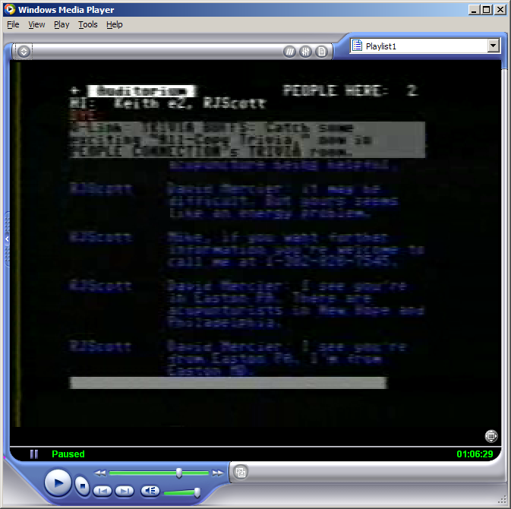
Must have been a SYSOLM?
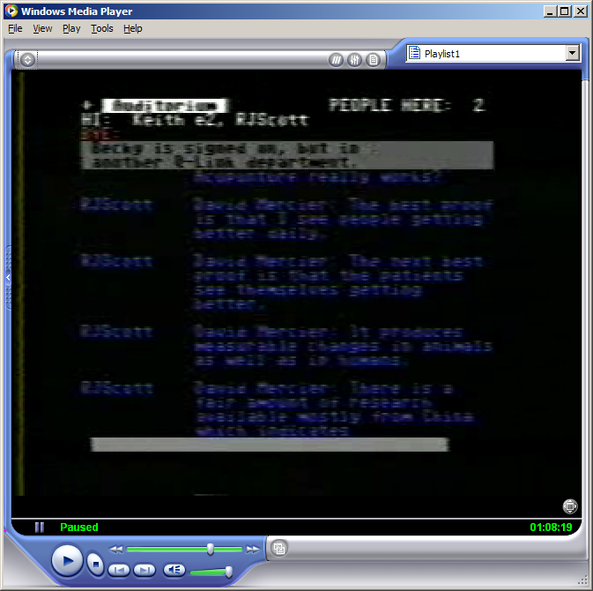
Locate verbiage
Also saw “User is not signed on.”
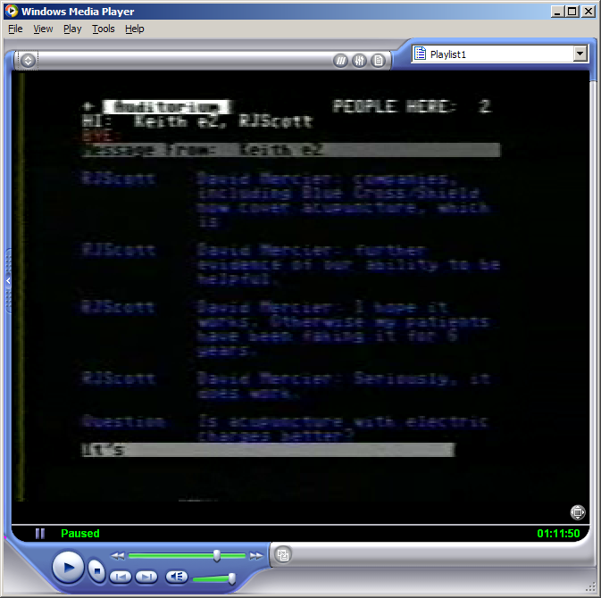
See how questions are shown?

Q-Link -=* It’s DOOR PRIZE time *=-

Quantum is pleased to award a door prize at EVERY event held in the Auditorium. The

Winner’s name is generated at random from among guests present IN the Auditorium!

RJScott What’s the door prize tonight Q-Link?

Q-Link Our door prize is *5000* QPons which may be redeemed for ONE free hour online by

Visiting the Winner’s Circle in THE MALL!

RJScott Who’s our door prize winner Q-Link?

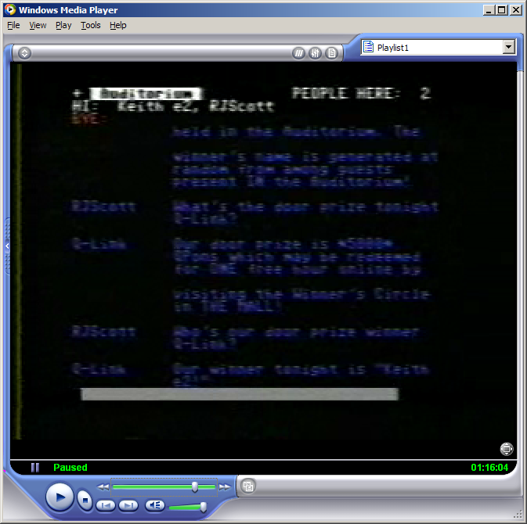
Notice the QLink thing and the blank line below it?

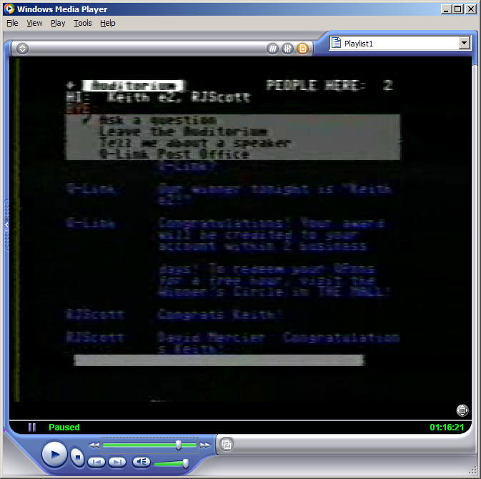
Winner’s Circle in THE MALL?
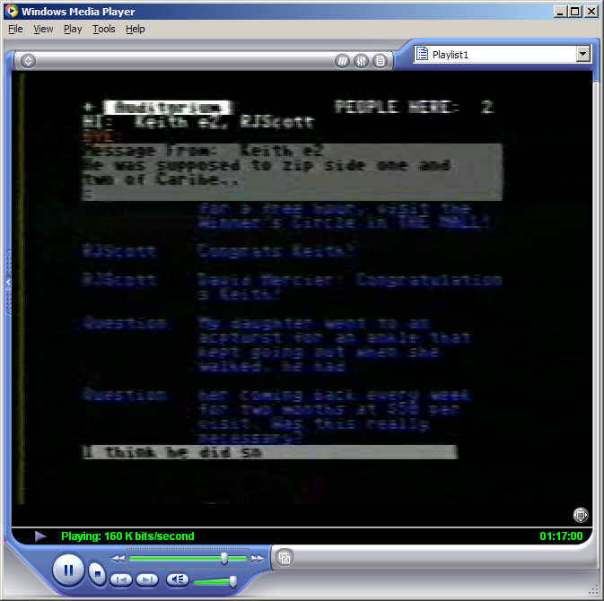
Long questions span two lines.

